Boulder Web Dev Meetup Madlib Program-A-Thon
Welcome to the Inagural Boulder Web Dev meetup and the Madlib Program-A-Thon! Just a few quick things about the competition and then we’ve outlined some of the key functionality/libraries you should know.
WIFI
Markit on Demand is offering public wifi. The wifi network name is MOD-meetup and the password is “mod-meetup” (all lowercase).
Rules:
- You need to include a madlib from: http://dev.markitondemand.com/Meetup/MadLib/GetMadLibJS (the example already has this so you should be good to start)
- Your page should require no interaction from the judges, they will simply open the htm file and your page should handle everything else. This means no click events, no hovers, etc.
- Entries will only be judged that are forked from the github. You will fork the gh-pages branch which will allow us to quickly judge all entries.
That’s pretty much it. Your mission is to take that chuck of Javascript and make the coolest webpage anyone has ever seen! (or at the very least get something presentable together in the short time period ☺ )
Setup:
- Fork the gh-page branch in the repo located on github: https://github.com/markitondemand/Meetup
  - Have questions on GitHub see below, or ask us for help
- Check out index.htm, this is where the magic happens
  - We have two approaches to get you started see more details below
- Once you have made your changes make sure to commit and push your fork, this is where we will look during the judging. There is no need to submit a pull request since we will be judging the entries individually. Be sure to commit and push early to allow time for the gh-pages to compile on the github servers.

Libraries:
jQuery - is required as some of the other libraries rely on it. Feel free to add as many different JavaScript libraries as you like and see the section about jQuery.noConflict(); if you don’t want jQuery mucking up the ‘$’ variable
MadLibEngine.js – this is a required file as it helps wrap up the basic functionality you can use to parse and work with your madlib, how you use it is up to you. The file is heavily commented however we will also include a breakdown of the methods in this doc
Util.js – this file is setup to help with adding APIs into your project and wrap up some of the hooks provided in the MadLibEngine.js. If you have any questions about the Util.js file ask around or try to find Ali Khatami or Antonio Reyes. If you can’t find them ask around or just have a crazy confused look on your face and we will probably find you.
Starting Points:
Option1 -
<!-- SIMPLE OPTION: UNCOMMENT THIS SECTION TO USE THE STANDARD MADLIB
<script src="http://dev.markitondemand.com/Meetup/MadLib/GetMadLibJS"></script>
<script src="http://dev.markitondemand.com/Meetup/MadLib/GetMadLibWordsJS"></script>

This is a great approach if you don’t want to deal with JSONP and other APIs we’ve plugged in in the Util.js file. With this approach the words and html (for the madlib) are added onto the page at page load. Like the comment says just uncomment this block (make sure to comment out the other block) and you are ready to run!

Option2 –
<!-- FUN/API OPTION: UNCOMMENT THIS SECTION TO USE APIS -->
<script src="Content/js/Util.js"></script>
<script>

This is the default approach, in the example you will see the Utils class wrap up the JSONP calls to get the words and the html, then in HandleWordPreFill you can see how the API calls work. We have outlined a couple of fun ones to get you started.

Data Structures:

Madlibs –
Returned from http://dev.markitondemand.com/Meetup/MadLib/GetMadLibJS as a string of html and stored in “madLibEngine.templateHTML”
The basic structure will look like this:
<div class="madLib">
<div class="title">My Madlib</div>
<span class=”sentence”> This is <span data-ML="noun_person"></span>’s favorite</span>
</div>
- where data-ML will designate the word that needs to be filled in to complete the mad lib.

Word Collection –
Returned from http://dev.markitondemand.com/Meetup/MadLib/GetMadLibWordsJS as a JSON object stored in “madLibEngine. wordCollection”
The basic structure is:
{wordCategory1: [word1, word2, word3], wordCategory2: [word1, word2]}
The way the engine is setup is that when it parses the template it will find data-ML=wordCategory1 and use the first word in the array, and the next time it finds data-ML=wordCategory1 it will use the next word. This process will complete until it hits the end of the array at which point it will start over

MadLibEngine.js

setupWordCollection(oArgs) – this function sets up the word collection used for parsing the template. It will use the words in wordCollection or alternatively you could pass oArgs.data equal to a json object that adheres to structure outlined above, for an up-to-date list of the different word categories

getTemplateFragment() – returns a DOM fragment of the madlib template – unparsed

addTemplateToPage() – takes the madlib template appends it to <div id=”madLibContent”> - unparsed, then returns the template as a DOM element

addAndFillTemplate() – takes the madlib template appends it to <div id=”madLibContent”>, then parses the template using parseHTML and fills the word entries using fillNextWord, returns the template as a DOM element

parseHTML(element) – takes the madlib template as the ‘element’ finds all the <span data-ML=””> elements a creates an array that fillNextWord will populate, returns the same element that was passed in

fillNextWord() – no inputs/return, walks through the elements as created in paresHTML and fills in the word corresponding to the category. This function will call preFillHandler before filling the word, and will call postFillHandler at the end of function call.

preFillHandler(element, currentWord, wordCategory) – element is a DOM element of the span element needing a word, currnetWord a string containing the current word to be filled in, category a string as indicated by the element. This function should return true if the current word should be used in the element. This method is basically empty and meant to be overridden if you would like hook on the behavior on how the template fills

postFillHandler(element) – element is a DOM element of the span element that was just potentially filled (see preFillHandler). By default this function only calls fillNextWord, again meant to be overridden to extract control over the template fill

Util.js

Util.js is a simple prototyped class that has quite a few API calls setup and ready to go for you. The purpose of this class was to allow people to quickly and easily create a rich madlib with images, videos, or other types of search responses. The project is already setup and ready to run, but you can customize it as much as you like.

Initialization

Util is a global variable on the window that instantiates new Utilities(). This means that you already have a Util class at your disposal, but the class is not initialized and the madlib will not run or add to the page until you call Util.Initialize();. The page is already setup to call Util.Initialize() when the entire dom is loaded and ready. We recommend not changing this. See a breakdown of the initialize method below.

Important Methods

Initialize(BingAPIKey, LastFMAPIKey, NetflixAPIKey) – Initialize should be called after the dom is ready. The method takes 3 arguments, all strings, and all API keys. In order to use the specific APIs you must specify your own key. If you use the default keys you will most likely encounter issues due to throttling by the APIs and enforced limits. The initialize method sets some Url Variables in context and also calls SetupMadLib() (see below for details)

SetupMadLib() – SetupMadLib will fire JSONP requests to Markit On Demand servers to get you the madlib html slug along with a dictionary of madlib words by category. Once the calls return the method sets up necessary overrides to make API calls work correctly and then calls madLibEngine.setupWordCollection and madLibEngine.addAndFillTemplate (see above for details) After this method is complete the Mad Lib html will be on the page and it will begin the process of filling in words using the API calls.

HandleWordPostFill(Element) – This is an override for madLibEngine.postFillHandler (see above for details). which just fills the next word in the madlib after a 1 second delay. Feel free to override this method on your page or in another script.

HandleWordPreFill(Element, CurrentWord, WordCategory) – This is an override for madLibEngine.preFillHandler (see above for details) which determines what should be done to the span where the word will appear. This is where all the awesome API calls happen. If you wish to use multiple APIs that’s fine, but just know that at some point you will need to call fill next word. The page has an example of a local override for HandleWordPreFill and that should help guide you to making awesome examples.

GitHub Quickstart Guide:

Your first step will be to install Git on your machine, the best/easiest tutorial can be found here: http://help.github.com/win-set-up-git/

Once you are setup, you’ll need to fork the repo located at https://github.com/markitondemand/Meetup

There is a guide here: http://help.github.com/fork-a-repo/ however if you’re not a fan of command line you can do this pretty quick and easy with GUIs.

From the repo located above click the fork button:
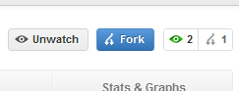
This will kick off the process; once it’s complete you will see the same files in your account. At this point launch the git gui:
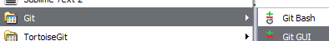

From there click “Clone Existing Repository”

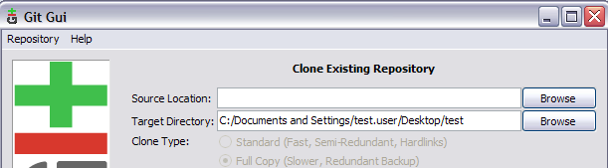

The target directory is where you want the files on your computer for the source you should grab that from GitHub, in your account looking at the forked repo select this field:

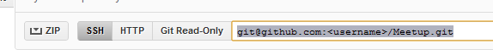
You’ll want to make sure you are using the gh-pages branch as this will build your project when you push it back to the server so we can view your page at: username.gethub.com/Meetup
To do this start by creating the gh-pages branch on your local machine:

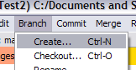

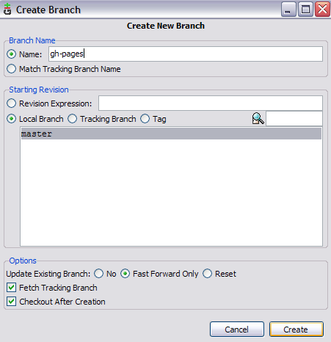

Once you have edited the files you’ll need to push them back into your repo before the judging can begin. From the Git GUI select “Rescan” to see your changes and then “Stage Changes”

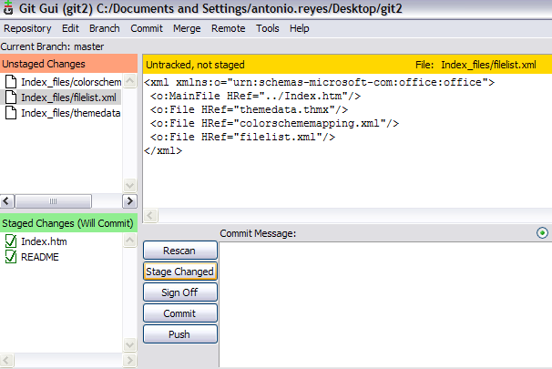

Then commit your changes, this creates record of the change in your local repository, and then finally you will need to “Push” the changes (make sure to push to gh-pages)

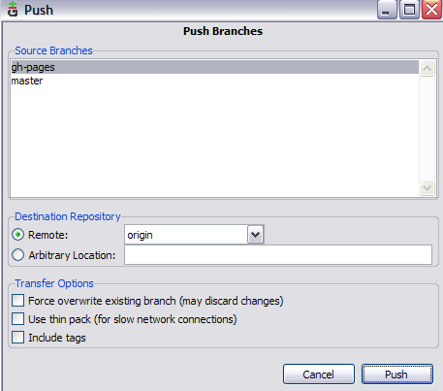

This will move your changes back onto github. Congratulations you’re done!

Github GUI Alternatives

Alternatives to github GUI for windows include github for Mac and tortoisegit which can be found with a simple google search. If you are having trouble with github just ask around and someone should be able to help get you setup.

